Water Quality Characterization report
2022
Certified by

_____________________________ __________
John Barlow, MSD Administrator Date

_____________________________ __________
Laura Bowley, CPMSM Date

Muncie Sanitary District, Delaware County, Town of Yorktown, and Ivy Tech- Yorktown
__________________________________________________

Water Quality Characterization Report
This report is a required submittal in accordance with Indiana’s new Stormwater General Permit, formerly 327 IAC 15-13-7, and must “use the most current data available but may also consider additional data that describes the chemical, biological, and/or physical condition of the receiving waters of the MS4 jurisdictional area”. Evaluation of this data will assist the MS4 operator in determining areas or discharge points in need of additional water quality measures.
History of water quality analysis in the MS4 boundaries
The Muncie Sanitary District’s (MSD) Bureau of Water Quality (BWQ) has been monitoring water quality in the West Fork of White River and its tributaries within Delaware County since 1972. The BWQ is responsible for the implementation of cooperative industrial pretreatment programs, daily chemical and microbial analyses of treatment facilities and stream water, and annual biological surveys of aquatic communities. Monthly chemical samples are taken at 12 sites along the West Fork White River and its tributaries (upstream of their confluence with White River). Three of these sites are sampled five days a week as well. Due to the higher frequency of these sample points compared to the six-year rotation of sampling that IDEM is able to accomplish, the analysis within this report uses data from the Bureau of Water Quality.
Jurisdictional Boundaries
The co-permitted MS4 consists of the urbanized areas of Delaware County, the City of Muncie/Muncie Sanitary District, the Town of Yorktown, and Ivy Tech- Muncie.
Figure 1. Entities within the MS4 (Urbanized Area) boundaries.
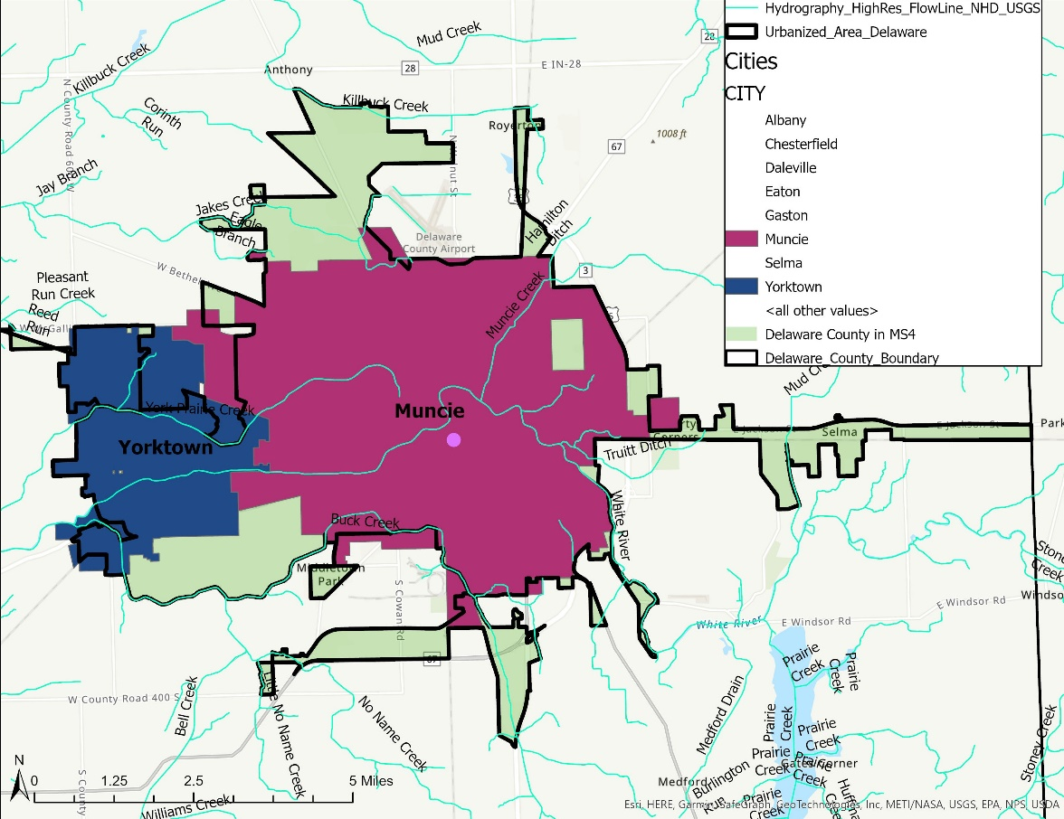
Identification of receiving waters
Table 1. Storm sewer discharges are permitted into the following HUC 12 watersheds and receiving waters within the MS4:
HUC-12 Subwatershed
51202010109 | Mud Cr.- White River
51202010110 | Truitt Ditch- White River
51202010111 | Hamilton Ditch- White River
51202010203 | No Name Cr.- Bell Cr.
51202010204 | Macedonia Cr.- Buck Cr.
51202010301 | Mud Cr.- Killbuck Cr.
51202010302 | Jake's Cr.
51202010303 | Thurston- Killbuck Cr.
51202010305 | York Prairie Cr.- White River
Receiving Waters
32 Ditch | Killbuck Cr.
Bell Cr. | Lennox Ditch
Buck Cr. | Little No Name Cr.
Eagle Branch Cr. | Mud Cr.
Fuson Ditch | No Name Cr.
Greenfarm Ditch | Truitt Ditch
Hamilton Ditch | Unnamed Trib to YPC
Holt Ditch | York Prairie Cr.
Jake's Cr. | West Fork White River

Table 2. 303d listed waters within the MS4:
Basin | HUC-12 | Assessment Unit Name | Parameter | IR Cat
West Fork White River | 51202010110 | White River | PCBs/Fish Tissue | 5B
West Fork White River | 51202010110 | White River (PWS) | PCBs/Fish Tissue | 5B
West Fork White River | 51202010110 | Truitt Ditch | PCBs/Fish Tissue | 5B
West Fork White River | 51202010110 | White River- unnamed trib | PCBs/Fish Tissue | 5B
West Fork White River | 51202010110 | White River | PCBs/Fish Tissue | 5B
West Fork White River | 51202010111 | White River | PCBs/Fish Tissue | 5A
West Fork White River | 51202010203 | Bell Cr. | E. coli | 5A
West Fork White River | 51202010203 | No Name Cr. | E. coli | 5A
West Fork White River | 51202010203 | Little No Name | E. coli | 5A
West Fork White River | 51202010204 | Buck Cr. | E. coli | 5A
West Fork White River | 51202010204 | Buck Cr. | PCBs/Fish Tissue | 5B
West Fork White River | 51202010204 | Buck Cr. | Biol. Integrity | 5A
West Fork White River | 51202010305 | York Prairie Cr. | E. coli | 5A
West Fork White River | 51202010305 | White River | PCBs/Fish Tissue | 5B

Table 3. Receiving waters with TMDLs (all for E. coli):
HUC-12 and Stream
51202010109 | White River | 51202010111 | Muncie Cr.
51202010109 | Mud Cr. | 51202010301 | Killbuck Cr.
51202010109 | White River - unnamed trib | 51202010302 | Jake's Cr.
51202010110 | White River | 51202010303 | Killbuck Cr.
51202010110 | White River (PWS) | 51202010305 | White River
51202010110 | Truitt Ditch
51202010110 | White- unnamed trib
Figure 1. Subwatersheds with the MS4.
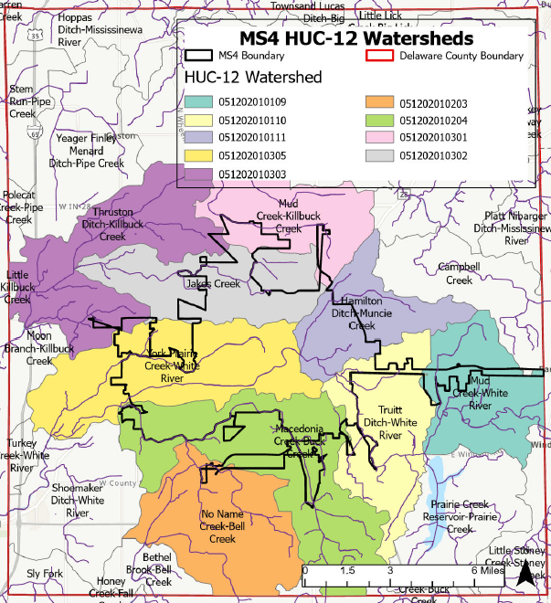
Land Use
Land use analysis was assessed (Table 4) for the 2004 Baseline Characterization Report. Since there has been little change, the analysis is used for this report.
Within the MS4, residential and commercial developments dominate the landscape. Contaminants associated with these land uses include sediment from construction and impervious surface runoff, hydrocarbons, road salts, trash, and E. coli from domesticated animal waste. Beyond the MS4, land use is predominantly agriculture. This implies that many of the waterways coming into the MS4 are already impacted by seasonal sedimentation from agricultural fields, and nutrient enrichment from fertilizers, livestock, and wild animals.
Figure 2. Land use in MS4 and Delaware County.
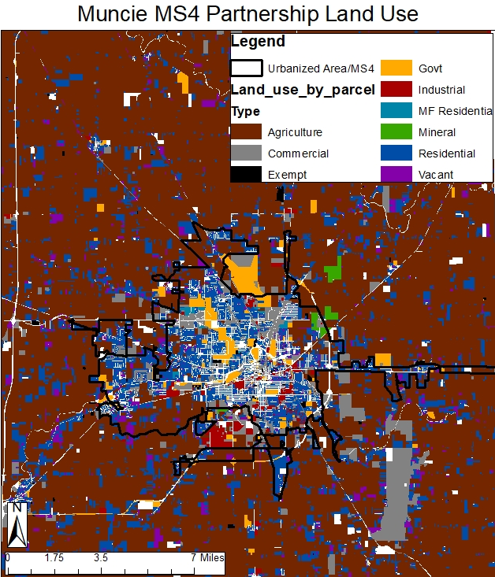
Land Use in MS4 Permit Area
Open water | 1.10%
Low intensity residential | 41.00%
High intensity residential | 8.10%
Comm/Industry/Transport | 18.40%
Deciduous forest | 4.50%
Evergreen forest | 0.10%
Pasture/hay | 3.90%
Row Crops | 15.80%
Urban/recreational grasses | 6.60%
Woody wetlands | 0.40%
Table 4. Land Uses within the MS4.

Inventory of MS4 owned/operated structural management measures
See Appendix A for an inventory of all MS4-owned/operated structural mgmt. measures, ID, coordinates, and condition.
Identification of sensitive areas
Sensitive areas are defined by the Indiana MS4 General Permit as “public swimming areas, drinking water intakes, habitats associated with threatened or endangered species, and outstanding state and national waters”. The following is an assessment of the sensitive areas located within the MS4.

- Habitat for Threatened and Endangered Species
In 2007, information regarding the presence of habitat for threatened or endangered species within the MS4 was obtained for the Long-Term Control Plan from the Indiana Natural Heritage
Data Center (IDNR) and the US Fish and Wildlife Service (US Dept of the Interior). According to
this communication, habitat for the state endangered Kirtland’s snake (Clonophis kirtlandii) is
found in a small area along Buck Cr. In addition, wooded riparian areas within and along
White River and Buck Cr. within Delaware County are considered to be prime habitat for the
federally and state endangered Indiana bat (Myotis sodalis). Wooded riparian habitat is
available throughout most of the length of White River and Buck Cr. within the MS4,
making nearly all riparian areas potential habitat for the Indiana bat. Weathered shells of the
federally and state endangered clubshell (Pleurobema calva) and northern Riffleshell
(Epioblasma rangiana), and federally threatened and state endangered Rabbitsfoot (Theliderma
cylindrica) have been found inside of the MS4 boundaries, however, no live mussels of these
species have been reported from anywhere in Delaware County.
The BWQ has been monitoring aquatic species (fish, mussels, and macroinvertebrates) from Buck Cr. and the West Fork White River for over 30 years. The only listed species that have
been collected live (and re-placed in the stream per permit guidelines) within the MS4 have been the following Indiana Special Concern mussels: slippershell mussel (Alasmidonta viridis), spike (Eurynia dilatata), wavyrayed lampmussel (Lampsilis fasciola), and rainbow (Villosa iris).

Figure 3. Sensitive areas based on critical habitat for the Kirtland’s snake and Indiana bat.

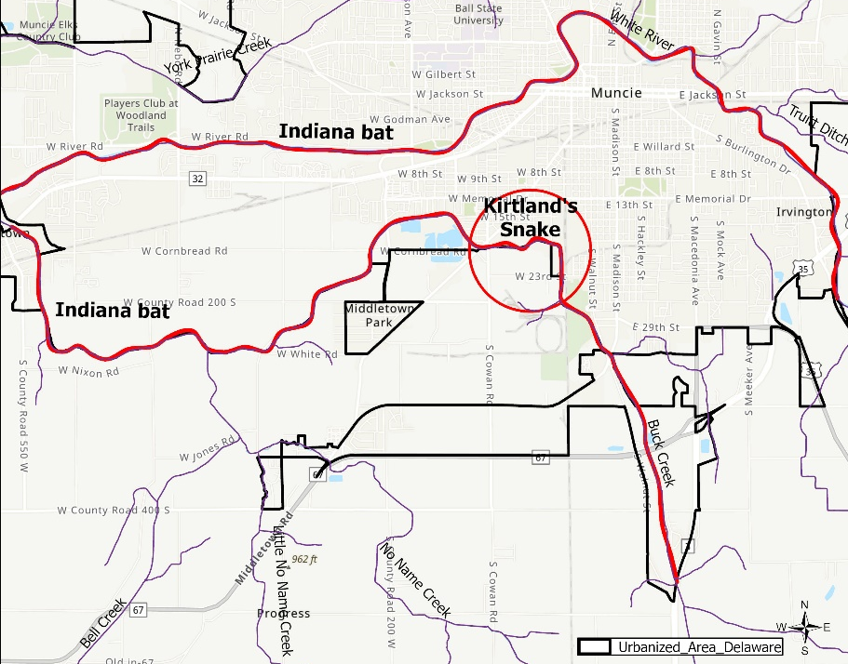
- Primary Contact Recreational Areas and Beaches
The IDEM standard for full body contact for E. coli s no more than 235cfu/ 100 mL in any one sample over a 30-day sampling period, or 125cfu/ 100ml as a geometric mean based on not less than five samples equally spaced over a 30-day period. Muncie’s watersheds have consistent readings of E. coli that are higher than these standards.
There are no recreational beaches within the MS4 area. Based on E. coli results exceeding the
235 cfu/ 100ml threshold set by Indiana, the MSD and BWQ have consistently discouraged full
body recreation in White River and Buck Cr. within the MSD boundaries through newspaper releases, public workshops/presentations, and the MSD website. While public parks are present along much of White River, none of these areas encourage swimming. All combined sewer
overflows along waterways are marked with signs that indicate the dangers of swimming after
wet weather.

- Drinking Water Source Waters
Information on water supply intakes and wellhead protection areas are no longer considered public information due to national security concerns. Local staff are aware of these areas and will address them through policies and procedures of the stormwater program.
- Outstanding Resource Waters
According to Indiana Administrative Code (327 IAC 2-1-11) and the Tier Three list of Outstanding National Resource Waters, there are no Outstanding State or National Resource Waters within the MS4.
- Sensitive Areas Conclusion
Based on this analysis, sensitive areas that must be considered for extra protection and
consideration include wooded areas along the West Fork White River and Buck Cr.
roughly between mile 7.0 and 8.5 within the MS4 area, as well as the undisclosed drinking water
source and wellhead protection areas.

Review and summary of existing and available monitoring data for the MS4 receiving waters
The BWQ has been monitoring water quality in the Muncie area for over 50 years. The BWQ’s data represent the most extensive and consistent sampling data available in the area, which includes near daily sampling from three locations on the on the White River and monthly sampling from select tributaries within Muncie’s city limits. To keep the results current, only the last five years of data (January 2017 to December 2021) will be considered. This will best represent more recent changes like the separation of some combined sewer overflows and the construction of a wet-weather storage facility, but it will still provide enough sampling points to effectively represent the conditions of the stream. Locations for sampling are provided in Appendix B.
Sample results are available from IDEM’s probabilistic watershed monitoring program. Because these samples are relatively low in number (typically only three locations every five years), they will not be used in this analysis other than to generally confirm the results from the BWQ. Other groups like Ball State University, the White River Watershed Project, and the Nature Conservancy periodically study water quality in the Muncie area, but these groups typically rely on BWQ data for samples in and around Muncie, so these data are already included our data sets.
Summary statistics were calculated for data from each of the sites in order to make general comparisons between stream quality. E. coli was the clear parameter of concern in the White River and its tributaries in Muncie. The primary contributor is Muncie’s combined sewer system which includes combined sewer overflows (CSOs) at 12 sites along the White River and Buck Cr. Muncie’s Long-term Control Plan will have these CSOs separated by 2031. Separation of CSOs alone will not be sufficient to reduce E. coli levels to safe limits as the White River regularly exceeds 235 cfu/100 mL upstream from the City’s CSOs.
E. coli
E. coli averages ranged from 766 cfu (White River- Memorial St) to 4013 cfu (Buck Cr.). Sites with
the highest averages and median scores at tributary sites- Buck Cr., Muncie Cr., Greenfarm
Ditch, Lennox Ditch, and Holt Ditch. The highest maximum E. coli readings occurred at White
River- 575W, White River- Tillotson, Buck Cr. and Muncie Cr. Average E. coli readings and
geometric means at all sites exceeded Indiana Water Quality Standards of 235cfu/ 100ml daily
and geometric mean of 125cfu/ 100ml. (327 IAC 2-1.5-8). Tributary sites at Buck Cr., Muncie Cr.,
Greenfarm Ditch, Holt Ditch, and Lennox Ditch all had >70% of all samples over the 235cfu
threshold daily.

- Dissolved Oxygen
Average dissolved oxygen at sites ranged from 7.2 mg/L at Lennox Ditch to 9.7 mg/L at WFWR
Tillotson Ave and 575W. Lowest minimum readings were found at Lennox Ditch, Buck Cr. and 32
Ditch. Many DO readings exceed the Indiana threshold of no less than 4.0 mg/L,
and all maximum readings exceeded the Indiana threshold of 12.0 mg/L (327 IAC 2-1-6).

- Nitrate-N
Nitrate-N averages ranged from 0.4 mg/L at Holt Ditch to 3.6 mg/L at WFWR- 575W. Maximum
scores were highest at White River sites, Buck Cr., Jake’s Cr., and Greenfarm Ditch. Indiana has a
maximum threshold of 10.0 mg/L in waters that are a drinking water source. (327 IAC 2-1-6).

- Phosphorous
Phosphorous average readings ranged from 0.06 mg/L at York Prairie Cr. to 0.35 mg/L at WFWR
575W. Phosphorous was exceptionally high (maximum, median and minimum) at WFWR- 575W,
with additionally high maximum readings at Muncie Cr., Truitt Ditch, and Mud Cr. There is
currently no Phosphorous threshold for Indiana, but there is draft Total Maximum Daily Limit
(TMDL) of 0.3 mg/L. The Ohio EPA Warmwater Habitat for Headwaters has recommended a
maximum of 0.08mg/L (Rankin et al. 1999).

- Total Suspended Solids (TSS)
Average TSS ranged from 19.0 mg/L at York Prairie Cr. to 37.0 mg/L in Truitt Ditch.
Maximum readings were highest at White River sites, Muncie Cr.., Truitt Ditch, and Mud Cr.
There is currently no threshold for TSS in Indiana. US EPA supports a threshold of 25.0-80.0 mg/L
set by the American Fisheries Society (Waters 1995).

- Turbidity
Average monthly turbidity readings ranged from 14.0 NTU at York- 400W to 54 NTU at Mud Cr.
Maximum scores were highest at White River sites, Muncie, Cr., Truitt Ditch and Mud Cr. There
is currently no threshold for turbidity in Indiana.

- Ammonia
Average ammonia readings ranged from .06 mg/L at WFWR- Memorial St to 0.18 mg/L at York
Prairie Cr. and Truitt Ditch. Maximum scores were highest at White Rivers sites and
exceptionally high at 32 Ditch. The Indiana ammonia threshold varies with pH and temperature
(0.0-0.21 mg/L) (327 IAC 2-1-6). Maximum readings at all sites exceed this threshold.

- Bacterial Oxygen Demand (BOD)
BOD average readings ranged from 1.29 mg/L at Truitt Ditch to 2.47 mg/L at Holt Ditch.
Maximum readings were highest at White River sites and 32 Ditch. There is no threshold for
BOD in Indiana surface waters.

- Pollutograph Study
In 2013, the MSD completed a pollutograph wet-weather study (Appendix C) to model the impacts of the CSOs. This study suggests complete separation may not be the ideal path to best reduce E. coli levels in the river. Partial separation would allow for the Muncie Water Pollution Control Facility to continue to treat the “first-flush” of stormwater and lead to higher water quality in the White River.

- Biological Sampling
Biomonitoring is conducted annually, with annual reports posted on the Muncie Sanitary District
website (https://www.munciesanitary.org/departments/bureau-of-water-quality/annual\reports/). Fisheries reports from 2017-2021 (for consistency with water quality data in Appendix B) consistently indicated a stark difference in water quality scores between White River and its tributaries. White River sites generally scored in the Fair to Excellent ranges, while tributaries generally scored in the Very Poor to Fair range. Macroinvertebrate scores (2017-2021), diversity and abundance were generally worse in the tributaries than White River.

Some sites or streams stand out as more impaired. Fisheries analysis pointed to the
Jake’s Cr. and York Prairie Cr. subwatersheds as being most impaired biologically and
physically based on IBI, mIWB and QHEI scores, potentially reflective of the much different soil
types and anthropogenic reactions to drainage difficulties because of them. Macroinvertebrate
IBI, QHEI and HBI scores suggested organic impairment at sites on York Prairie Cr., Buck
Cr., Greenfarm Ditch and Muncie Cr.
- Fish Consumption Advisories
Buck Cr. and the West Fork White River in Delaware County have advisories for several fish species due to PCB contamination (https://www.in.gov/health/eph/fish-consumption-a advisory/). This is not unusual in Indiana- the top two contaminants that primarily guide fish consumption advisories are mercury and PCBs.
Areas Potentially Causing Stormwater Quality Problems
This MS4 is subjected to the known pollutants associated with urban areas- increased runoff due to increased impervious surfaces, potentially with higher temperatures and carrying hydrocarbons, sediment, chemicals, pesticides, nutrients, pathogens, road salts, etc.
The examination of all data indicates some problem areas:
Truitt Ditch
Results show that this stream enters White River with high turbidity and total suspended solids, ammonia, phosphorous, and zinc.
Holt Ditch
This stream enters White River with high total suspended solids, turbidity, E. coli, phosphorous and BOD, and low DO.
Mud Cr.
Results show that this stream has high total suspended solids, turbidity, ammonia, and phosphorous.
Muncie Cr.
This stream has high total suspended solids and turbidity, temperature, E. coli, and phosphorous. Macroinvertebrate assessments suggest organic impairment.
Jake’s Cr.
Fisheries assessments suggest that Jake’s Cr. watershed (HUC-12) may be one of the most impaired biologically and physically.
Buck Cr.
This stream has extremely high E. coli, Nitrate-N, phosphorous and turbidity, zinc, and low DO.
Lennox Ditch
This stream has high E. coli and Nitrate-N, ammonia, BOD, copper, zinc, and low DO.
York Prairie Cr.
This stream has high ammonia. Fisheries assessments suggest that this stream may be one of the most impaired biologically and physically. Macroinvertebrate assessments suggest organic impairment.

Greenfarm Ditch
This site has high E. coli and Nitrate-N. Macroinvertebrate assessments suggest organic impairment.
WFWR- Memorial Ave.
This site on White River has that E. coli levels over the Indiana threshold before it flows through the urbanized area and any effects of the CSOs. It also has high Nitrate-N, TSS and turbidity, ammonia, and BOD.
WFWR- Tillotson Ave.
This site has high E. coli, Nitrate-N, phosphorus, total suspended solids and turbidity, ammonia, and BOD.
WFWR- 575W
This site has high E. coli, Nitrate-N, phosphorous, total suspended solids and turbidity, ammonia, and BOD. This is the downstream-most site in the study and is likely affected by the cumulative effects of all upstream impacts and tributaries.
Areas that need to be considered for future planning and implementation of new stormwater measures or modification of existing measures (Highest priority = sensitive areas and prohibition of new or significantly increased MS4 discharges)
Highest priority areas based on determined sensitive areas to be considered for future planning and implementation of new stormwater measures or modification of existing measures include the West Fork White River and Buck Cr. between stream mile 7.0 and 8.5, as well as the undisclosed drinking water source area and wellhead protection areas.
Additional review of the sampling data suggests that two small streams in Muncie, Holt Ditch, and Lennox Ditch, appear to be uniquely impaired in comparison to other streams in the city. Elevated levels of E. coli (despite the absence of CSOs in the stream), and slightly elevated levels of biochemical oxygen demand and certain metals suggest the possible impact of illicit discharges.
More extensive wet-weather analysis and outfall sampling is planned for the summer of 2023 to help identify and eliminate any illicit discharges on these streams.
One additional tributary was identified as needing more sampling, Watson Ditch. This stream will also be sampled in 2023 to help produce a baseline characterization.

References
E. Rankin, B. Miltner, and C. Yoder. 1999. Association between nutrients, habitat, and the aquatic biota in Ohio rivers and streams. Ohio EPA Technical Bulletin MAS/1999-1-1.
Waters, T.F. 1995. Sediment in streams: sources, biological effects, and control. American Fisheries Society. Bethesda, MS. 251 p.

Appendix A
MS4 Owned/Operated Structural Stormwater Management Measures

Appendix B
Water Quality Data

Appendix C
Pollutograph Study

